🧠 Crowbar vs Clamp
- Crowbar: Once triggered, it pulls voltage down to near zero and stays latched until power is removed.
- Clamp: Limits voltage to a preset level but doesn’t shut down the circuit entirely.

🔄 Active Crowbar Variant
Some advanced designs use transistors or GTO thyristors that can automatically reset after the transient is gone. These are common in high-reliability systems like wind turbines or industrial converters

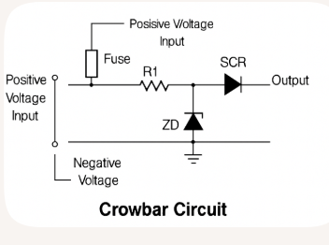
Circuit protection is essential for keeping electrical systems safe and reliable. Besides the crowbar circuit, there are several other types of protection methods, each designed to guard against specific faults like overcurrent, overvoltage, short circuits, and ground faults.

🔌 Common Circuit Protection Methods
Protection Method | Function | Typical Use Cases
Fuses | Melt when current exceeds a safe level, breaking the circuit | Household appliances, automotive systems
Circuit Breakers | Mechanically trip to interrupt current flow during overload or short | Residential panels, industrial equipment
Surge Protection Devices (SPDs) | Clamp high-voltage spikes to safe levels | Power strips, telecom systems
Metal Oxide Varistors (MOVs) | Absorb voltage spikes by changing resistance | AC mains protection, lightning arrestors
Thermal Circuit Breakers | Use heat to trip the breaker during overload | Motor control, HVAC systems
Ground Fault Circuit Interrupters (GFCIs) | Detect imbalance in current flow and shut off power | Bathrooms, kitchens, outdoor outlets
Residual Current Devices (RCDs) | Similar to GFCIs, used in European systems | Residential and commercial buildings
Electronic Current Limiters | Actively monitor and limit current flow | Power supplies, battery chargers
Reverse Polarity Protection | Prevent damage from incorrect power connections | DC circuits, battery-powered devices
TVS Diodes (Transient Voltage Suppressors) | Clamp fast voltage transients to protect sensitive components | Data lines, microcontrollers

🧠 Bonus Insight
Each method has its own strengths:
- Fuses are simple and cheap but need replacement.
- Circuit breakers are reusable and more versatile.
- MOVs and TVS diodes are great for fast, transient protection.
- GFCIs/RCDs are lifesavers—literally—when it comes to preventing electric shock.

